**Case Overview**

This case is created to manage the Loan Application of Bbold Loan Institute. We need an online Loan Application System at Bbold Loan Institute. Currently we review all loan applications manually. It’s tedious and time consuming. The system is designed to capture the applicant information, approve application credit rating 6.5 and above.

Here, I have covered the user/actor identification, requirement identication and gathering techniques. Also, I have prepared the BRD and FRD templates with use case diagram

**User Identification**

The Loan application system is built to retain the information of all applicant. We need the online system to capture the following information for each loan application:

* Name
* Address
* Yearly Income
* Yearly Expenses
* Number of Dependents
* Credit Rating

We need a way to automatically approve a loan application based on the applicant’s credit rating. If an applicant’s credit rating is 6.5 and above, the application should be approved. This will save us time and we will be more efficient in our business dealings.

When an applicant applies for a loan, the system checks if the rating is 6.5 and above and the applicant will be approved for the next step. Once the application is approved, the loan officer will contact the applicant to collect other documentation such as social security number and a form of ID. Further all approved application and documentation will be sent to the credit department who will provide the loan finance rate than to the manager for signature and approval finally we send the loan finance rate to the customer. The customer can then choose to accept the loan approval or reject it.

**Actors:**

1. Applicant

2. Manager

3. Credit Department

4. Loan Officer

**Use Case:**

1. Create account/ login
2. Gather information from client
3. Document verification
4. Process Document
5. Delegate to client

**Requirement Gathering Techniques**

1. Distributing **Questionnaire** to employees (they are many) to know their contact information, preferred payment method, work hour preference and so on.

2. Conducting **JAD** meeting with department heads of finance, HR and payroll administrator. Payroll administrator maintains the overall payroll system, HR hires and fires the employees and accounting department is responsible to issue the payment. So, JAD will be effective to make quick decision.

**BRD and FRD template**

|  |  |  |  |  |
| --- | --- | --- | --- | --- |
| **BR** | **Module** | **Entity Involve** | **Description** | **Requirement** |
| BR 1 | Login & Logout | Applicant | Applicant Login | Applicant First & Last Name |
| BR 2 | Personal information | Applicant | Address | Applicant Physical Address |
| BR 3 | Personal Information | Applicant | Yearly Income | Applicant Yearly Income |
| BR 4 | Income | Applicant | Yearly Expenses | Applicant Yearly Expenses |
| BR 5 | Dependents | Applicant | Number of Dependents | Applicant Number of Dependents |
| BR 6 | Credit | Applicant | Credit Rating | Applicant Credit Rating |

**FRD for Loan Application:**

Requirement Code:

B1

* TR1 The system shall capture the first name of all loan applicant
* TR2 The system shall ensure that the first name is no longer than 25 characters
* TR3 The system shall display an error message if first name character exceeds 25 characters
* TR4 The system shall display the following error " first name cannot be more than 25 characters"
* TR 5 There shall be no numbers in the first name
* TR 6 The system shall display an error if a first name contains any numbers
* TR 7 The system shall capture all a loan applicant last name
* TR 8The system shall ensure the last name doesn't exceed 30 characters
* TR 9 The system shall display error message " do not exceed 30 character" if a character exceeds 30

B2

* TR 1 The system shall require the address of all loan applicant
* TR 2 The system shall ensure all address have street name, city, state and zip code
* TR 3 The system shall display an error if street name, city, state and zip code is not a display
* TR 4 The system shall ensure that each street name is no longer than 30 Characters
* TR 5 The system shall display an error if street name exceeds 30 character
* TR 6 The system shall display the following error " Street name exceed 30 Characters"

B3

* TR 1 The system shall ensure that all loan applicant enter their Yearly income
* TR 2 The system shall refuse all weekly or hourly income
* TR 3 The system shall refuse a letter for yearly income
* TR 4 The system shall display error message "letters are not accepted only numbers

B4

* TR 1 The system shall require for a loan applicant enter their yearly expenses
* TR 2 The system shall ensure that yearly expenses are only numbers
* TR 3 The system shall display error if the letter are enter for yearly expenses
* TR 4 The system shall capture if the yearly expenses surpass the yearly income
* TR 5 The system shall capture only numbers
* TR 6 The system shall display an error if letter is being used
* TR 7 The system shall display an error message if expenses Exceed Yearly income " Your expenses exceed your yearly income"

B5

* TR 1 The system shall capture the number of dependents of the loan applicant
* TR 2 The system shall ensure numbers of dependent are reflect in numbers

B6

* TR 1 The system shall capture the number of dependents of the loan applicant

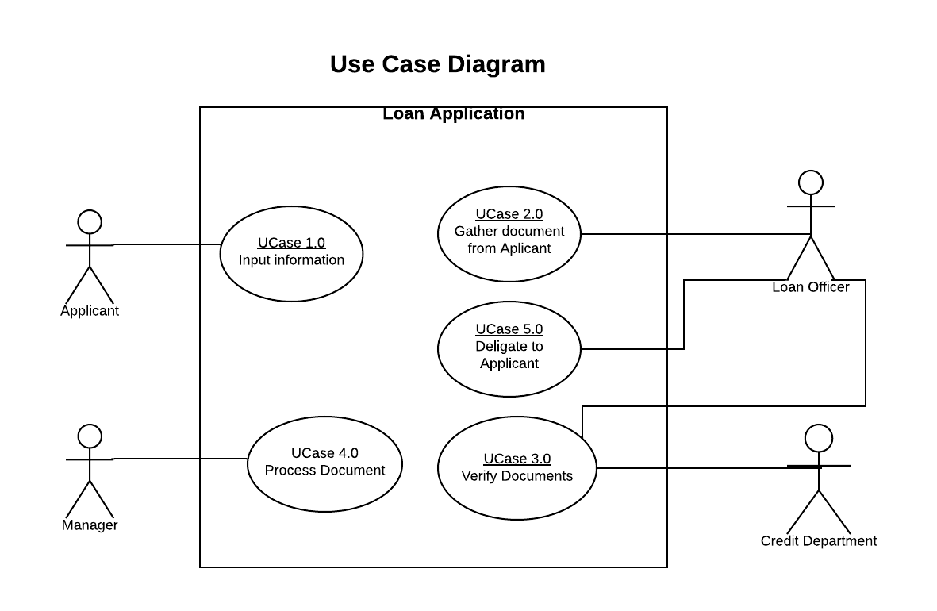

**Use Case Index**

|  |  |  |  |  |
| --- | --- | --- | --- | --- |
| **Use Case Id** | **Created By** | **Created At** | **Primary Actor** | **Description** |
| **UCase 1.0** | Fariela Sambo | 3/28/20 | Applicant | Input Information |
| **UCase 2.0** | Fariela Sambo | 3/28/20 | Loan Officer | Gather document from Applicant |
| **UCase 3.0** | Fariela Sambo | 3/28/20 | Loan Officer /Credit Department | Verify document |
| **UCase 4.0** | Fariela Sambo | 3/28/20 | Manager | Process Document |
| **UCase 5.0** | Fariela Sambo | 3/28/20 | Loan Officer | Delegate to Applicant |

**Scenario**

**Use case: Create account/ login**

1. **Use Case Name:** Create account/ login
2. **Use case Brief Description**

This use case allows all categories of employees to update the time card information

1. **Flow of Events:**

The Use case starts when employee wishes to create/edit/update/view his loan application.

If Applicant wishes to create the login account the following sub flow is performed:

3.1 Applicant request the system to create new account

3.2 System will present the following information to the applicant to fill in.

* New Username: (First name & Last Name)
* New Password (consist of at least one Upper case, lower case, consist of at least one number and special characters ….)

3.3 System will ask Applicant to enter Username & Password again and will proceed if information is filled in correctly

3.4 System will ask applicant to fill in personal Information

* Fil in their full First & Last Name (varchart First Name 25/varchart Last Name 30).. Next screen
* Fill in their physical address (street name, city, state and zipcode) Next Page ……
  + Applicant is required to fill in physical address
  + If applicant do not fill in physical address applicant can’t proceed
* Applicant should provide accurate Yearly Income, Next Page…….
  + If applicant do not have income, applicant cannot proceed with application/process will END
* Applicant should provide accurate Yearly expenses, Next Page…...
  + If applicant can NOT provide a yearly expense the credit rate should be 7.0 and above
  + If applicant can provide an accurate yearly expense credit score can be 6.5 and above
* Applicant must present the number of dependents, Next Page ……
  + This is not required/ it is an option
* Applicant should provide appropriate credit rating, Next Page ……
  + If applicant can NOT provide a credit rating, process can NOT proceed.
  + If credit rating is below 6.5 process will END
  + If credit rating is 6.5 and above process will proceed.

3.5 System will ask applicant if all information is correct, and will show all information the applicant fill in.

* Applicant click YES, Process will continue to Submit
* Applicant Click NO, Process will give option to correct information

3.6 System will Show your application, has been successfully submitted, Thank You

**Use case: Gather client information**

**1. Use Case Name:** Gather Information from applicant

**2. Use case Brief Description**

This use case allows loan officer to gather information/ document from client

**3. Flow of Events:**

The Use case starts when Applicant was approved by system

3.1 Loan officer Login to system and check applicant status.

* Was approved (action required from Loan Officer)
* Was declined (No action required from Loan Officer)

3.2 When application is approved by system, Loan Officer contact applicant to upload further documentation.

3.3 After applicant submit Social Security, Bank Statement, A form of valid ID, Officer check and approved the documentation.

3.4 Loan Officer submit approved document to the Credit Department

**Use case: Document Verification**

**1. Use Case Name:** Verify Document

**2. Use case Brief Description**

This use case allows the credit department to verify all the applicant documentation

**3. Flow of Events:**

The Use Case starts when Credit Department receive the document from Loan Officer

3.1 Credit Department login into system

* Received approved documents from loan officer

3.2 Check System for correct Social Security Number

* Invalid Social Security Number (Contact Applicant)
* Valid Social Security Number (Proceed with application)

3.3 Check ID for correct information

* Invalid ID information (Contact Applicant)
* Valid ID Information (Proceed with Application)

3.4 Calculate the amount of Loan

3.5 Submit calculated amount alongside the verify document to the manager

**Use case: Process Document**

**1. Use Case Name:** Document Processing

**2. Use case Brief Description**

This use case allows managers to process the applicant documentation

**3. Flow of Events:**

The Use Case starts when the manager receives the documents from the credit department

3.1 Manager Login to the system

* Receive Verify document from Credit Department

3.2 Go through the documents, sign and approve

3.3 Sent document to the Loan Officer

**Use case: Delegate to Client**

**1. Use Case Name:** Gather Information from applicant

**2. Use case Brief Description**

This use case allows loan officer to delegate the loan finance to the applicant

**3. Flow of Events:**

The Use Case starts when the loan officer receives the sign documents from the Manager

3.1 Receive sign document from Manager

3.2 Contact Applicant to delegate result and sign

**Activity Diagram**

**Use case: Create account/ login**

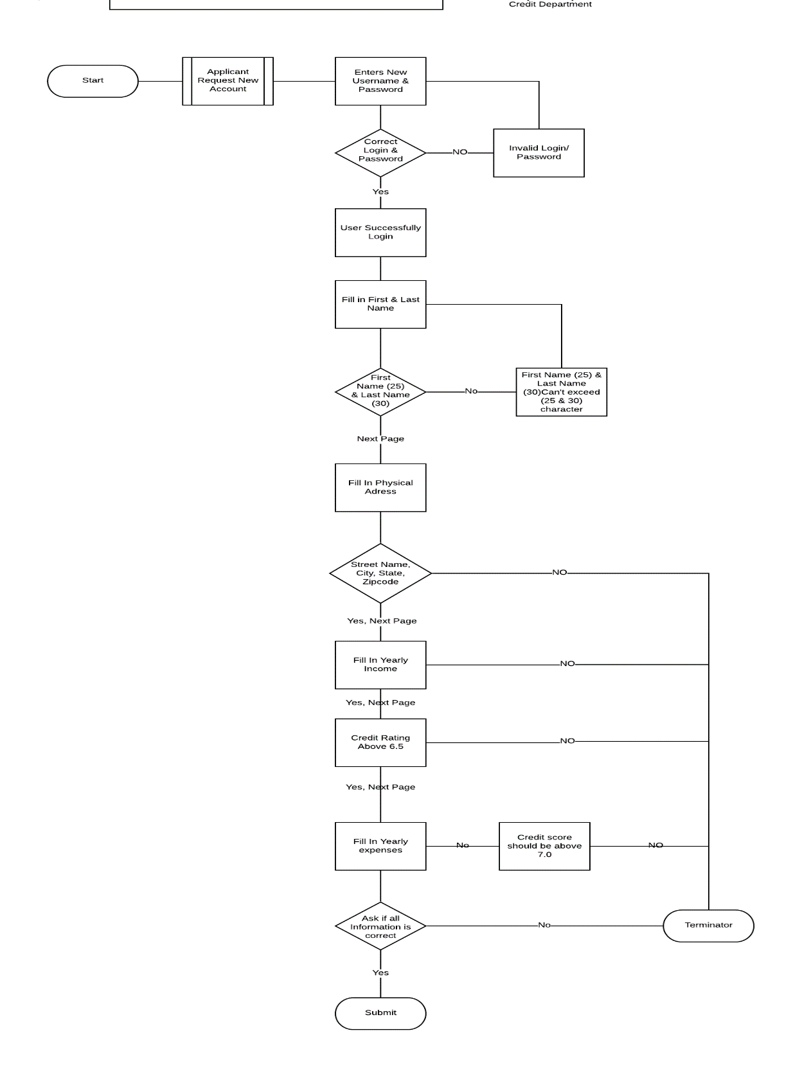

**Use case: Gather client information**

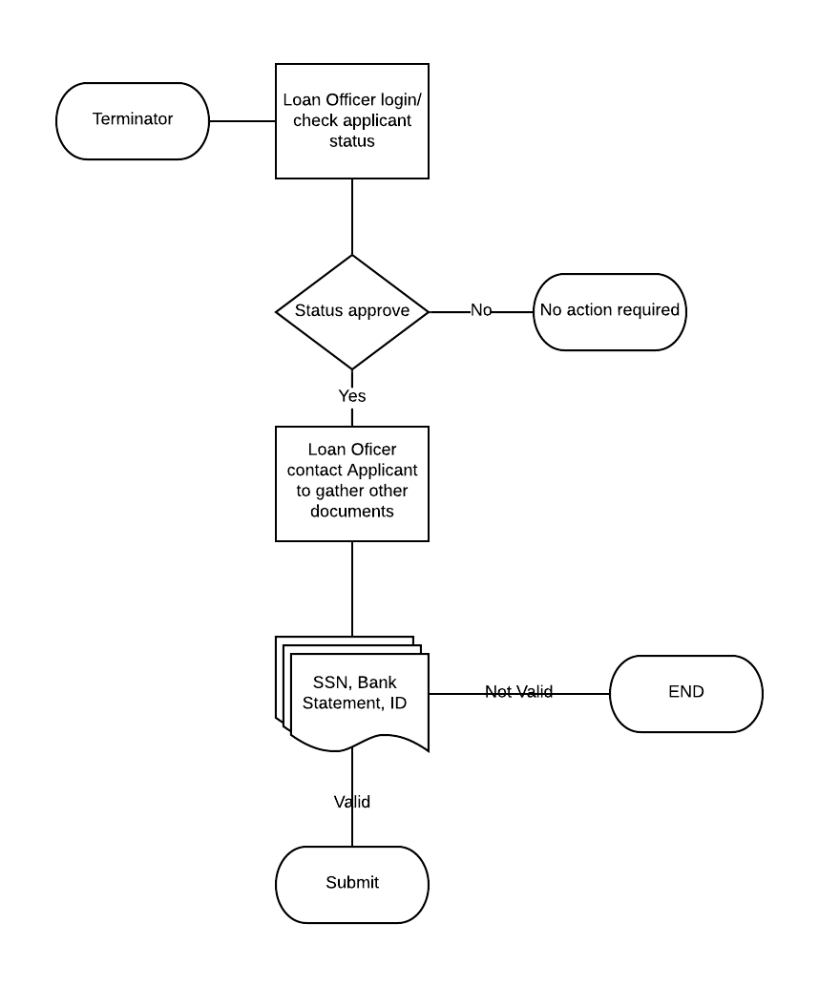

**Use case: Document Verification**

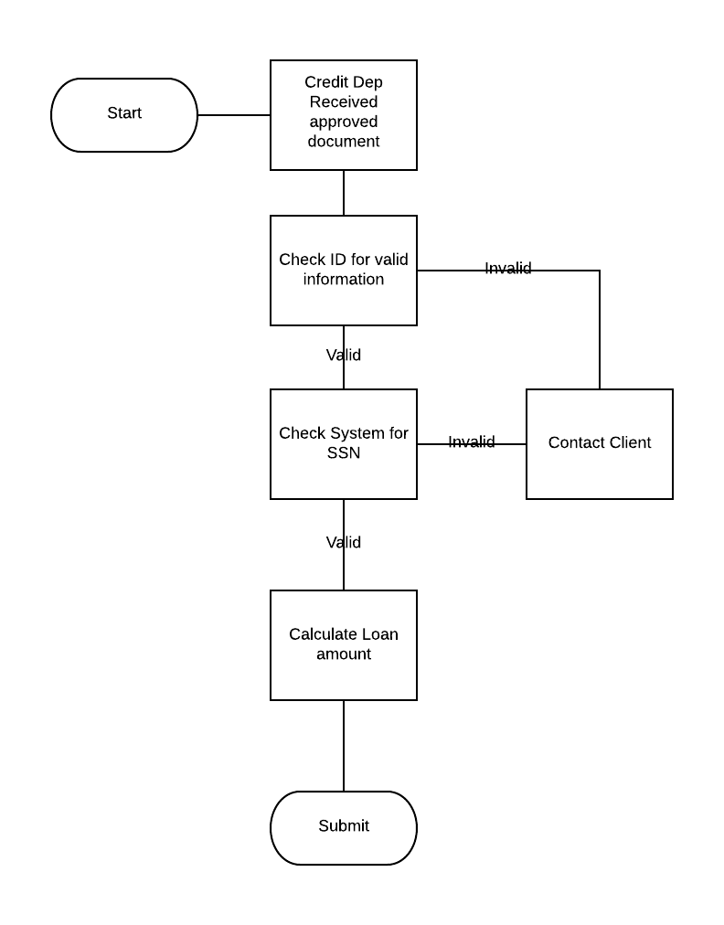

**Use case: Process Document**

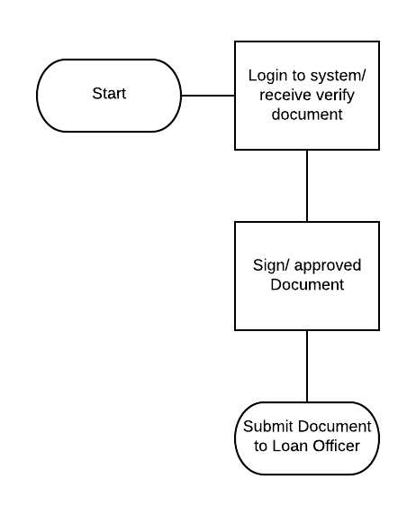

**Use case: Delegate to Client**

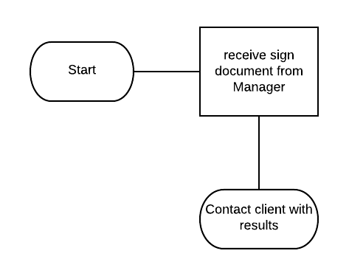

**Test Case**

|  |  |  |  |  |  |  |  |
| --- | --- | --- | --- | --- | --- | --- | --- |
| **Test Case ID** | **BR** | **TR** | **Test Case Description** | **Test Data** | **Expectation** | **Author** | **Result** |
| TC1 | B1 | TR1 | Create account/ login | **123@@11** | **Pass** | **Tester Aron** |  |
| TC2 | B2 | TR2 | Gather client information | **123@@12** | **Pass** | **Tester Aron** |  |
| TC3 | B3 | TR3 | Document Verification | **123@@13** | **Pass** | **Tester Baren** |  |
| TC4 | B4 | TR4 | Process Document | **123@@14** | **Pass** | **Tester Baren** |  |
| TC5 | B5 | TR5 | Delegate to Client | **123@@15** | **Pass** | **Tester Baren** |  |

**ERD Diagram**

We have four entities

* Applicant
* Loan Officer
* Credit department
* Manager
* Document

